Focus this week
With staff and student induction complete, we turn our attention to the year ahead. The first big event this year is our Open Evening on 20 September, closely followed by a week (possibly two if needed) of Open Mornings. In order to ensure open events have the least impact possible on students’ education we’re holding our Open Evening on a Wednesday. This means that, with the exception of the homework club, there will be no clubs on Wednesday 20 September after school.

Travel update
Road safety is a huge consideration for us in school as I know it is for you at home too. As we grow again this year the stress on our car park and the pedestrian routes out of school are clear. Of course, when our school was designed, we expected that by this point in our development we’d be taking large numbers of students from the new Mowbray housing but that building has not kept pace with the original timeline. In order to ensure our children are as safe as possible when making their way to and from school, we must continue to work together. The first step in that, as every year, is gaining an understanding of how families expect their children to travel to and from school. With our travel survey, we’re now at 50% completion. Without those additional numbers I cannot try again to put pressure on local service providers to make the bus companies serve the school directly or to put in additional traffic calming measures, I just don’t have the numbers to back up the argument. If you haven’t already done so then please do take five minutes to complete the survey, here. If you’re not sure if you’ve completed it, check your inbox for ‘Travel Survey July 2023’ as we will have sent you a copy of your responses. Once I have all the information available, I will write to families again with a travel specific letter outlining next steps.

Clubs timetable
The new clubs timetable will be starting next week, Monday. You will find the timetable here when it’s finished and we will let you know via classcharts announcements as soon as we’ve posted it.
Library
Please could you check whether you have any outstanding library books at home as there are many which are now overdue from last term.
Curriculum Overview: What is my child learning and why?
One of the most effective things a family can do in supporting their child at school is to be inquisitive about what their child is learning. Our Curriculum Leaders have put together a document that captures just this - an overview of what you can expect your child to encounter through their school journey. It is a glimpse of some of the incredible experiences, encounters and content your child will wrestle with as they move through their time with us.

Bohunt Horsham Curriculum Overview

This document is a live document and will be updated by Curriculum Leaders throughout the year (e.g. our Year 11 curriculum will be coming soon). We are proud that our school curriculum is adaptive and, while the content for examinations largely remains the same, our 2 year KS3 and our 3 year KS4 programme enables us to respond to happenings in the world and changes experienced by young people. In short, we can meet young people where they are at and adapt to their changing needs. Therefore if you would like to find out more about what your child is learning, please do not hesitate to reach out to the Curriculum Leaders directly for more information.

GCSE information
In addition to the curriculum overview document which will show you the term by term content for each subject, a reminder to year 9-11 families that the Bohunt Horsham GCSE page is available to access through our website https://www.bohunthorsham.com/curriculum/gcse-information/ The subject area pages on the home page require a Bohunt Horsham login so are visible only to students. However, whatever point you are at in the GCSE journey, I would recommend exploring the resources available in the drop down “GCSE exam preparation” to support you in understanding your child’s journey as a GCSE student. The page “Exam timetables” is for year 11 families only and will be populated with more specific information about upcoming mocks/ exams. General information about upcoming assessments for all year groups can be found as normal on the Bohunt Horsham home page under calendar https://www.bohunthorsham.com/families/calendar-2/

Canteen
Information about our canteen and termly menus can be found here.

Personal Development
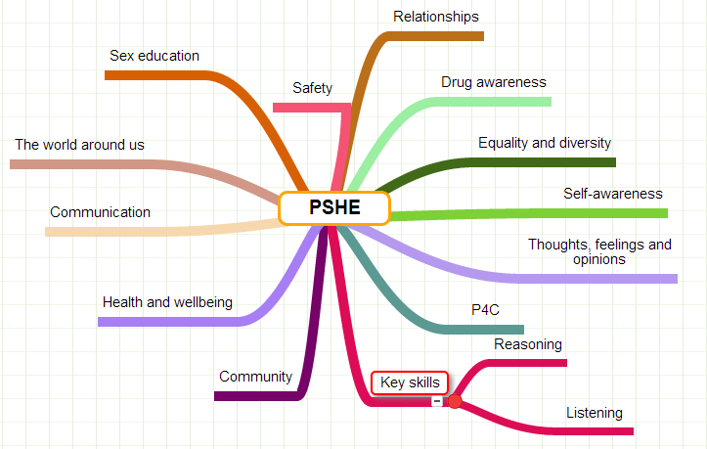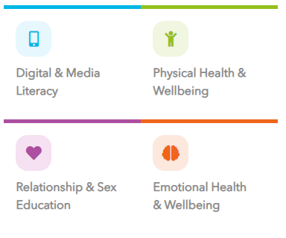
At Bohunt Horsham, we teach personal development through our tutor times and occasional drop down days. We have developed our curriculum using ‘Educating for Safeguarding’ From West Sussex County Council.

The delivery of personal development does not officially start until after half term, however, on 27th September there is a drop down day. All timetabled lessons are suspended and students will be taking part in activities from their pastoral team, form tutors and external agencies. There is an exciting and inspirational day planned for each year group.

The following topics will be covered either in tutor time or from external agencies:

Year 7: Online safety (from Childnet) and road safety
Year 8: Online safety (from Childnet), Knife crime (from Sussex Police) & The Connor Saunders Foundation
Year 9: Violence Prevention (from Sussex Police) & Vaping and drug awareness (From Drug Sense)
Year 10: Drug and Alcohol (From Drug Sense) & Wellbeing
Year 11: Drug and Alcohol (From Drug Sense) & Pregnancy



For parents and carers:
Drug sense is offering a parent/carer workshop at Bohunt Horsham Main School Hall, 27th September, 6pm-7.30pm. To book your place please complete this form:

The presentation will be an update for parents/carers on the current drugs scene, update on county line activity, tips and advice on what to keep an eye out for in respect of suspected substance misuse.


Could you be a hero?
Give us 15 minutes of your time and you could well give a child back the rest of their life …
On Sunday 17 th September from 9am to 2pm local charity Issy’s Silver Linings and friends will be in the
car park at Bohunt School Horsham with a drive through Swab To Save A Child station enabling anyone
between the ages of 17-55 years to:

- collect a swab kit
- fill in a quick online form on your phone
- swab your cheek and go.

The swab kits will be returned to the UK’s largest bone marrow register, DKMS, who will check to see if
you are eligible to join their register. Too many children are not finding their match and only 3% of the UK population is currently on the register. 2,000 people will be searching for a match this year and only
25% will find it the way we did – via a sibling.

Too scary? Did you know that 90% of donors give their cells in a similar way to giving blood?

And the the other 10%? You can chat to Issy’s Silver Linings very own superhero donor during the event. She’s 12. She’s given her cells to her big sister Issy. Twice. And not the easy way either… and she’d do it all again if she was asked.

Join her and save a life.

Important Dates

September
12 Sep | School Photographs - Year 7, 9 and 11
26-29 Sep | Open mornings for September 2024 intake
20 Sep | Year 6 Open evening
22 Sep | INSET Day - School closed to students
October
9-20 Oct | BET Assessment Fortnight
13 Oct | Y7/8 Drama Performance - Beware the Jabberwock
23-27 Oct | HALF TERM
 | School calendar: https://www.bohunthorsham.com/families/calendar-2/

