

SEND information report

Bohunt Horsham is committed to providing an inclusive education for all students during the school closure due to COVID-19. This means that all students have access to 1-2-1 and small group support should they need it. Students and their families should communicate via email and/or google classroom if they require any additional support.
Introduction

If you would like this report read to you can download a reader for free at http://www.naturalreaders.com/ or simply open the link and click + documents then drag the file into the box. A glossary of terms and SEND acronyms is also included at the end of this report.

For a link to the local authorities’ local offer please click this link: https://www.westsussex.gov.uk/education-children-and-families/special-educational-needsand-disability-send/send-local-offer/

For a link to the West Sussex Local Offer Annual Report please click this link: https://westsussex.local-offer.org/information_pages/369-annual-report-west-sussex-localoffer

You can find the most up to date SEND Code of Practice via: https://www.gov.uk/government/uploads/system/uploads/attachment_data/file/398815/SEND_Co de_of_Practice_January_2015.pdf

The schools SEND policy can be found via: https://bohunthorsham.com/statutory-information/

Bohunt Horsham is a mainstream secondary school and member of the Bohunt Education Trust. We are a fully comprehensive, non-selective school recruiting from a large number of local primary schools. We believe that all children should be valued as individuals. We have an inclusive ethos underpinned by high expectations and challenging, exciting lessons. We offer a broad and balanced academic curriculum. Teaching is differentiated to incorporate individual needs and we have in place systems to enable the early identification of barriers to learning and participation.

Special educational provision is provision that is additional to or different from that made generally for others of the same age. This means provision that goes beyond the differentiated approaches and learning arrangements normally provided as part of high quality, personalised teaching. It may take the form of additional support from within a subject area or require involvement of specialist staff or support services. All teachers are teachers of children with SEND and as such provide quality first teaching that takes account of the individual needs of children with SEND in their class.

The Special Educational Needs and Disability code of practice: 0 to 25 years (May 2015) states that there are four main areas included in Special Educational Needs and Disability

Area of Special Educational Need | Relating to difficulties with:
Communication and  Interaction | Children and young people with speech, language and communication needs (SLCN) have difficulty in communicating with others. This may be because they have difficulty saying what they want to, understanding what is being said to them or they do not understand or use social rules of communication.  Pupils may have a need in one or more of the following areas:  Attention / Interaction skills:  - May have difficulties ignoring distractions.  - Need reminders to keep attention.  - May need regular prompts to stay on task.  - May need individualised motivation in order to complete tasks.  - Difficulty attending in whole class.  - Interaction will not always be appropriate.  - May have peer relationship difficulties.  - May not be able to initiate or maintain a conversation.  Understanding / Receptive Language:  - May need visual support to understand or process spoken language.  - May need augmented communication systems  - May have frequent misunderstandings.  - Repetition of language and some basic language needs to be used to aid their understanding.  Speech / Expressive Language:  - May use simplified language and limited vocabulary.  - Ideas / conversations may be difficult to follow, with the need to request frequent clarification.  - Some immaturities in the speech sound system.  - Grammar / phonological awareness still fairly poor and therefore their literacy can be affected.
Cognition and Learning | Support for learning difficulties may be required when children and young people learn at a slower pace than their peers, even with appropriate differentiation.  Pupils have difficulties with the skills needed for effective learning such as use of:  - Language, memory and reasoning skills  - Sequencing and organisational skills  - An understanding of numbers  - Problem-solving and concept development skills  - Fine and gross motor skills  - Independent learning skills  - Exercising choice  - Decision making  - Information processing

Social, Mental and  Emotional health | Children and young people may experience a wide range of social and emotional difficulties which manifest themselves in many ways. These may include becoming withdrawn or isolated, as well as displaying challenging, disruptive or disturbing behaviour.  These difficulties may lead to or stem from:  - Social isolation  - Behaviour difficulties (ODD/EBD)  - Attention difficulties (ADHD/ADD)  - Anxiety and depression  - Attachment disorders  - Low self esteem  - Issues with self-image
Sensory and / or Physical | These pupils may have a medical or genetic condition that could lead to difficulties with:  - Specific medical conditions  - Gross / fine motor skills  - Visual / hearing impairment  - Accessing the curriculum without adaptation  - Physically accessing the building(s) or equipment.  - Over sensitivity to noise / smells / light / touch / taste.  - Toileting / self-care.

The school provides a range of "ordinarily available provision" to meet the needs of all of our pupils. This is a graduated response to each child dependent on the level of need. These are often referred to as waves of intervention.

Wave 1: Quality first teaching through differentiation in lessons and support by a tutor. Wave 2: Small group support for those pupils who are achieving below age expected levels. Wave 3: Focused, individualised programmes for pupils working well below age expectation.

Key Questions

Who is Bohunt Horsham’s Special Educational Needs Coordinator? | The SEND coordinator is Mrs N Jones who can be contacted via the school office on 01403 627430 x215 email njones@bohunthorsham.com  Mrs Jones is also a maths teacher and member of and Achievement Coordinator at the school with experience working with vulnerable students. She is currently studying for the masters SENCo accreditation course at Winchester University.
How accessible is the site of Bohunt Horsham? | Bohunt Horsham is currently based at Arun House, Hurst Road in Horsham. It was refurbished in Summer 2019 and has a ground floor, first floor and second floor. The ground floor is fully accessible via the main entrance and via ramps throughout the site. The first floor can be accessed via lift. There are also accessible toilets and changing facilities on the first and ground floor. The second floor is currently not used for teaching.

How will The Bohunt Horsham staff support my child? | All teachers will be informed of your child’s individual needs and will seek to adapt their lessons accordingly.  Within school there are a variety of staff roles to support your child.  Where the school considers it necessary a student may be offered additional intervention, in which case you would be informed via letter.  There are a range of interventions and additional subject support which are available, and should your child need this, it would be discussed with you directly. This will form part of the Assess-Plan-Do- Review process (diagram included at the end of this report). Parents will be clearly informed via letter that an intervention is beginning.  Wave 1 interventions:  - Differentiation within the classroom  - Banded groups and in some cases smaller sized classes  - Guidance to staff on how best to support within the classroom.  - Homework/study club  Wave 2 interventions:  - Lexia (reading support)  - Supported homework club  - Small group intervention for English and Maths  Wave 3 interventions:  - 1-2-1 Mentoring  - 1-2-1 EAL support  - 1-2-1 Emotional support
How will Bohunt Horsham identify if my child has a specific need? | Following completion of baseline tests upon entry to year 7 we will then further test a selected group of students who have registered a standarised score beneath the average range (SS100). From these tests we will identify if they require a specific access arrangement. Parents will be made aware via letter that their son/daughter will be tested and also of the recommended outcome. Students will be tested again in year 8 and then finally in year 9 in preparation for  GCSES.

 | It is important to note, that your son/daughters access arrangements can change and aren’t confirmed until the end of year 9 when they are tested for the final time. Final arrangements awarded will be in line with the JCQ guidelines and where a full history of need is available.
How are Bohunt Horshams resources allocated and matched to children’s special educational needs? | We ensure that all children who have Special Educational Needs have their needs met to the best of the school’s ability with the funds available.  We have an extremely small team who are funded from the SEND budget and deliver interventions designed to meet the needs of children both in small groups and on a 1-1 basis where appropriate.
How will I know how my child is doing and how will you help me to support my child’s learning? | All Parents will receive a termly report from subject staff. Parents evenings are held at specific points in the year and in addition to these the SENCO holds regular review meetings throughout the year that parents can request.  Students with an Education and Health Care Plan (EHCP) will have regular meetings with the Student Support Team together with an Annual Review in line with the Code of Practice 2015. We consider that the parents/carers’ views are a vital part of the review and therefore request your attendance at the meetings and the completion of parental paperwork prior to the meeting. Students without an EHCP but with significant barriers to their learning may have an Individual Support Plan written and agreed between the SENDCo, parents and students. In this, strategies are agreed and targets are assessed which are reviewed throughout the year.
How will my child be able to contribute their views? | If your child has an EHCP their views will be sought before review meetings and their opinions sought on how they best like to be supported when writing and reviewing Individual Support Plans.  We value and celebrate each child being able to express their views on all aspects of school life. Students are encouraged to share issues with:  - Tutor  - Achievement Coordinator  - SENDCo  Students are encouraged to:  - Take an active role within their tutor group activities / programme  - Take part in student leadership activities  - Attend review meetings  - Contribute to target setting and reviewing  - Attend extra-curricular clubs

What support will there be for my child’s overall wellbeing? | All staff are trained to deliver high quality pastoral care.  The Schools Pastoral Support Team specialises in the area of student welfare and is the first port of call for staff, students and their parents who require advice, support and guidance regarding student wellbeing.  Attendance is rigorously monitored and support put in place where needed. All pupils are within a House and receive many opportunities for rewards and celebrations.  We also offer the following Wellbeing Interventions:  - Mindfulness  - 1-2-1 mentoring sessions  - Emotional support  Bohunt Horsham is mindful of the need to safeguard the wellbeing of all students and management of first aid arrangements will be undertaken in such a way as to ensure there is adequate training of staff, provision of first aid equipment and recording of first aid treatment.  If your child finds lunch or break times tricky we have staff on duty monitoring quiet areas of the school in order to support them.
What specialist services and expertise are available or accessible by Bohunt Horsham? | We have access to the following specialist services and expertise:  - Nursing  - Counselling  - Medical – GP, Hospital  - Nursing – school nurse service  - EP Service  - Mental Health – CAMHS  - Youth Centre  - Allsorts Youth project  - Social Services  - IPEH (Integrated prevention and earliest help)  - LBAT (Learning behaviour advisory team)  - APC (alternative provision college)  - Educational Psychology service  - Police  - Pupil Entitlement Team  Where a student has an Education and Health Care Plan, the school maintains close liaison with the specialist Teacher Teams and/or medical services, as required.
What training are staff supporting students with SEND had or are having? | All teaching staff have qualified teacher status or are working towards if they are completing a PGCE or Schools direct placement. Training for staff supporting students with SEND is considered essential. There is an ongoing programme of training for Learning  Support Assistants.

SEND forms part of the new staff induction programme. In addition, there is regular training in first aid, child protection and safeguarding, and any looked after children on roll.

Advice and guidance from outside agencies is shared with teaching staff. At the start of the year all staff are made aware of the students with identified SEND and how to find information relating to them to best support them in and out of the classroom.

All staff have access to relevant information detailing specific strategies and interventions which best allow them to support each individual with the classroom.
How will your child be | All staff running trips are trained by the schools EVC and must complete risk assessments including specific details of how to support students with SEND. We will also work with families and West Sussex County Council where there are complex needs to consider. All students are encouraged to be fully involved in all areas of school life. Where appropriate, students with an Education and Health Care plan will be supported to ensure access and participation.  All clubs and trips are open to students in line with a suitable risk assessment being carried out. Individual arrangements will be discussed with parents in advance.  Where a student has a physical/medical needs, any issues around trips and activities will be discussed in advance and addressed with parents.
included in activities
outside the classroom,
including school trips?
How will Bohunt prepare and support my child to join, transfer to a new setting/college or the next stage of education or life? | For students transitioning from primary to secondary we liaise with junior schools and provide additional transitional support if it is needed. This is arranged on an individual basis and tailored to the needs of the student/s. Meetings with the SENDCo are available at parent’s request in the Summer Term and encouraged for all students attending with an EHCP.  If a student has an EHCP then the school would want to be present at the year 6 annual review meeting to support target setting and also be introduced to all professionals supporting the student and establish an early relationship.
Who can I contact for | The following points of contact are available at Bohunt Horsham:
further information? | For academic and pastoral concerns:  - First contact should be with the class teacher  - Tutor and or Achievement Coordinator  - Head of Department  - Head of Faculty  - SENDCo

If your concern is in relation to your child’s Education and Health Care Plan, please contact the SENDCo in the first instance.
In the first instance contact the subject teacher and your child’s tutor who may refer your concerns to a more senior member of staff where required.

If your concern is relating to your child’s special educational need/s, please contact the SENDCo directly.

Should you wish to make a formal complaint regarding an issue at the school please following the complaints policy which maybe found on the website.
How else can you be involved? | We need you to support us by encouraging your child to fully engage with their learning and any interventions offered by  - Helping them to be organised for their day (including bringing the right equipment and books)  - Full attendance and good punctuality  - Completion of homework  - Checking and signing planner  - Attending parent’s meetings  - Attending any meetings specifically arranged for your child  - Ensure that any interventions that are to be completed at home are
What support is there for improving behaviour, attendance and avoiding exclusion? | As a school we have a very positive approach to all types of behaviour with a clear reward and sanction system that is followed by all staff.  Attendance of every child is monitored on a daily basis. Lateness and absence are recorded and reported on. Good attendance is actively encouraged throughout the school. If a student’s attendance falls beneath 90% contact will be made by the school in the form of letter and telephone call. In extremely circumstances the school may use the support of an Education Welfare Officer.
How are the Governors involved and what are their responsibilities? | An assigned school governor is responsible for SEND and liaises with the SENCo on a regular basis. The SENCo provides reports to the Governors to keep them informed. They are kept informed about SEND developments and take an active interest in the work of the department. They do not have access to information about individual students or become involved in individual assessments. In the unlikely event that a concern cannot be resolved by the SENDCo, then the SEND governor can be contacted at the request of parents.

Additional information

Please find on the next page a model of the Assess, Plan / Do / Review process that we following the SEND department. Please also find guidance on acronym’s used within special educational needs and disabilities.


Regular class assessment data identifies pupils making less than expected progress / baseline assessment data on entry indicates concerns.


Further assessment completed using the schools Assessment Toolkit.

Student Profile: Students strengths, difficulties, methods of support/ reasonable adjustments identified. Completed between student and SEND Dept staff.
Quality First Teaching planned. ‘Additional to or different from’ a normal differentiated curriculum Interventions planned. Intervention begins and students recorded on the Provision Map.
Relevant adjustments to the school environment planned / Specialist equipment applied for.

Student Profile reviewed with student.
Termly testing of Intervention. SENDCo collates information and reviews the impact of interventions on individuals and overall impact.
Further support from external professionals sought.
Education, Health and Care Plan applied for involving relevant professionals.
Education, Health and Care Plan reviewed in formal meeting.


Quality First Teaching. Additional Adult Support in lessons.
Intervention Style Support:
- Small Group Support.
- Pair Support.
- One-to-one support

Glossary of SEND Acronyms and Abbreviations
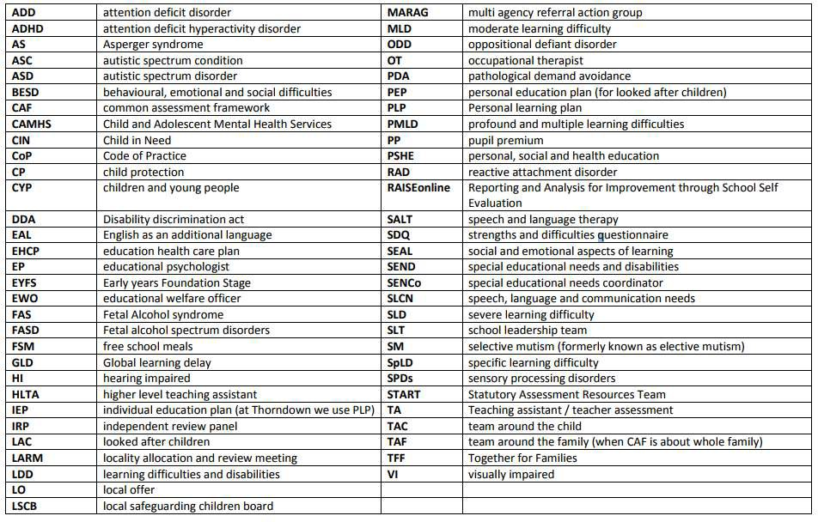

Published: October 2019
Review: October 2020

